AT2

Movie Database Application

Optimisation Report

Team Name:

Team Bare Maximum

Members:

Reece Pieri, Jose Rico Imbang, Say Hon Lee

Course:

Diploma of Software Development – Rapid Application design

Contents

1 Introduction 3

2 Code Optimisation Done for HTML 4

2.1 Index 4

2.2 Admin 4

3 Code Optimization Done for PHP 5

3.1 Admin 5

3.2 Connectors 9

3.3 Index 10

3.4 Mail 16

# Introduction

This optisation report shows the errors of the HTML and PHP code which have been fixed in the software.

We have chosen to use PHP CodeSniffer to do our code optimisation. We will include the numbers of errors remaining as well as the number of errors remaining in the code which could not be fixed by using the code optimiser.

# 2 Code Optimisation Done for HTML

2.1 Index

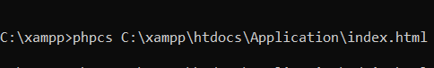

There is no error in the file, nothing have been changed.

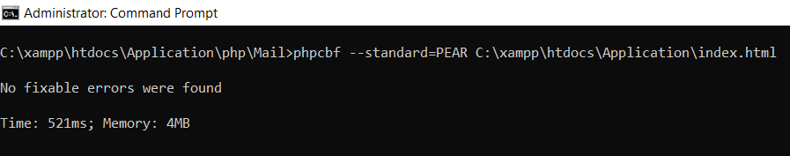

2.2 Admin

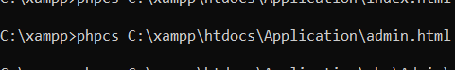

There is no error in the file, nothing have been changed.

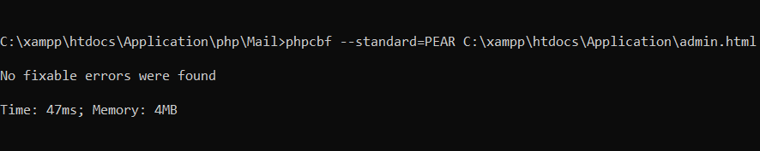

# 3 Code Optimization Done for PHP

3.1 Admin

This is the number of issue resolved by using PHP Code Sniffer for the whole of admin php file. The changes have been made and displayed in the end of the admin page screenshots.

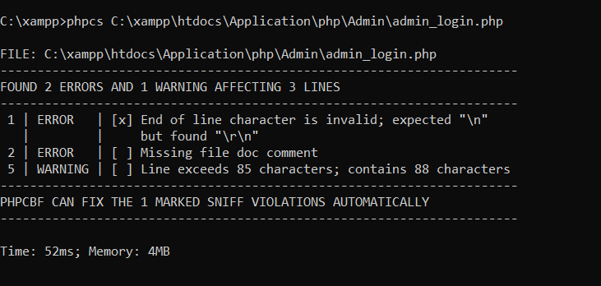

Initial amount of errors in admin_login.php

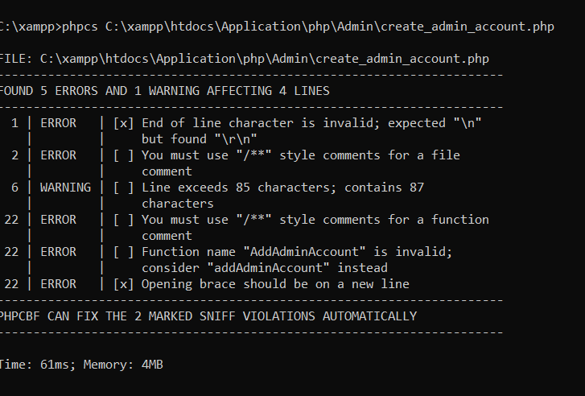

Initial amount of errors in create_ admin_account.php

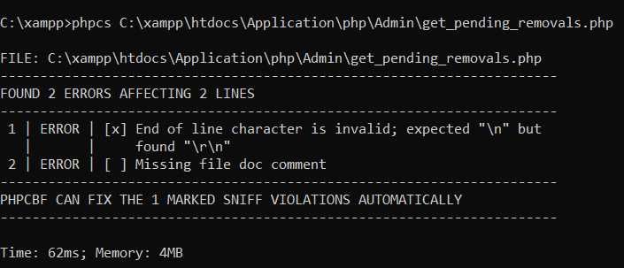

Initial amount of errors in get_pending_removals.php

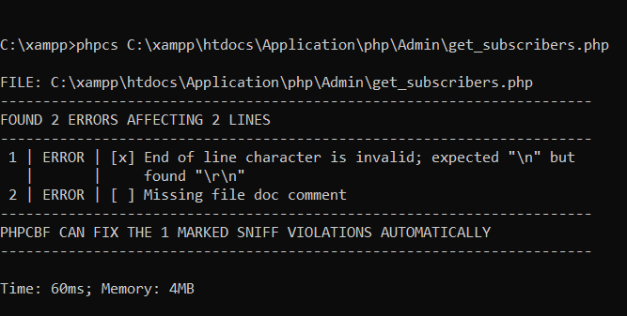

Initial amount of errors in get_subscribers.php

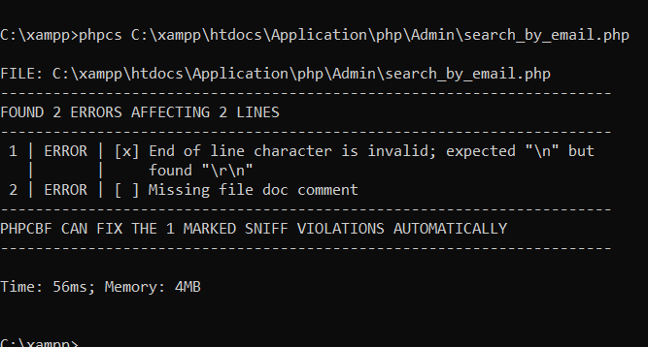

Initial amount of errors in search_by_email.php

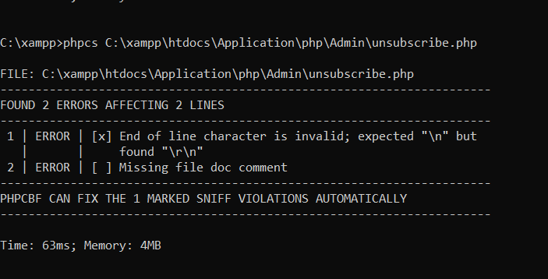

Initial amount of errors in unsubscribe.php

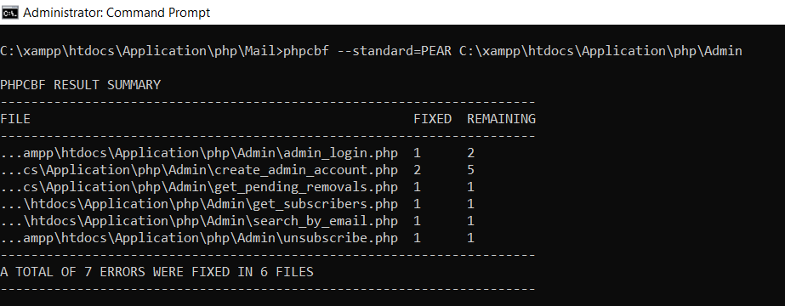

This shows the number of errors which have been fixed in the Admin file by using PHP CodeSniffer as well as the remaining amount of errors.

3.2 Connectors

This is the number of issue resolved by using PHP Code Sniffer for the whole of connector php file.

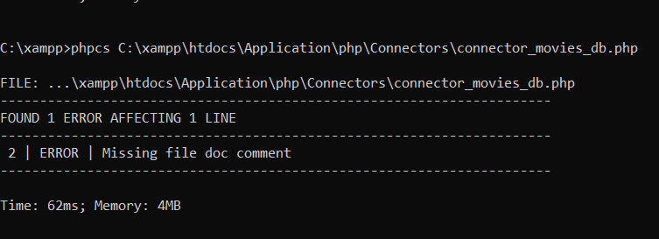

Initial amount of errors in connectors_movies_db.php

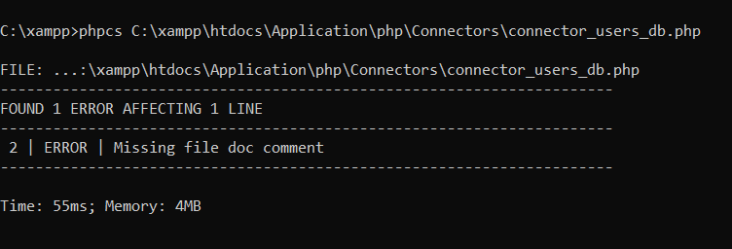

Initial amount of errors in connectors_users_db.php

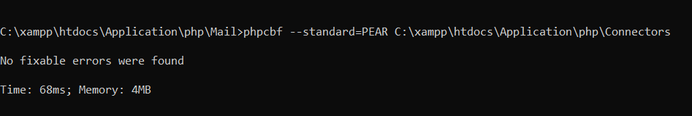

The error which occurs in the connector file could not be resolved by PHP CodeSniffer.

3.3 Index

This is the number of issue resolved by using PHP Code Sniffer for the whole of Index php file.

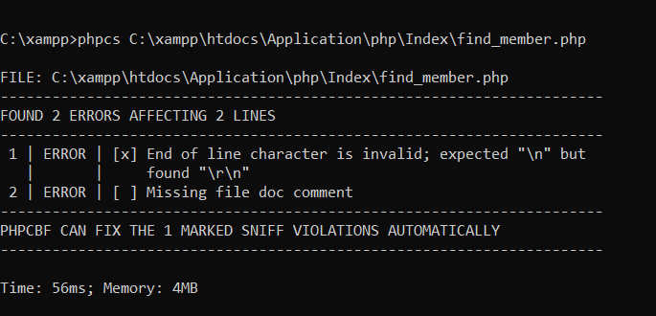

Initial amount of errors in find_member.php

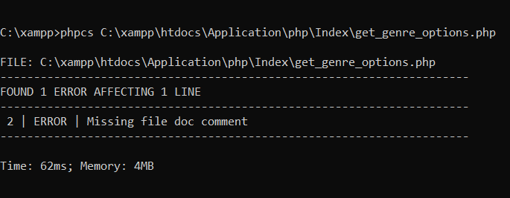

Initial amount of errors in get_genre_options.php

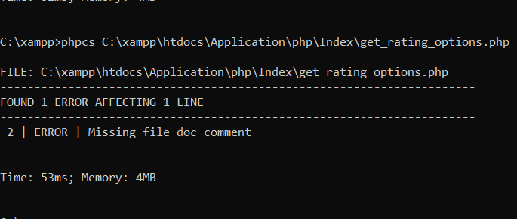

Initial amount of errors in get_rating_options.php

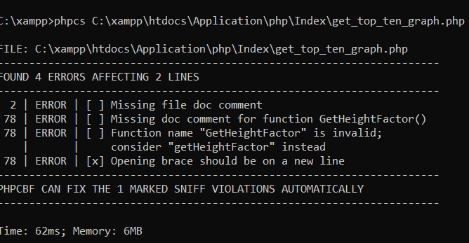

Initial amount of errors in get_top_ten_graph.php

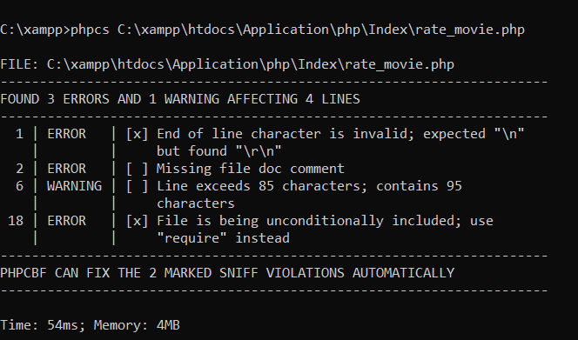

Initial amount of errors in rate_movie.php

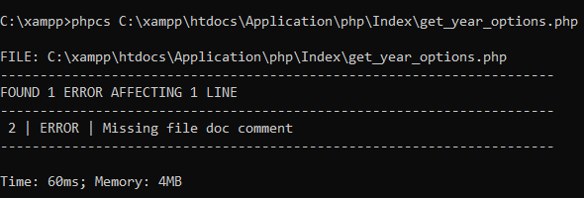

Initial amount of errors in get_year_options.php

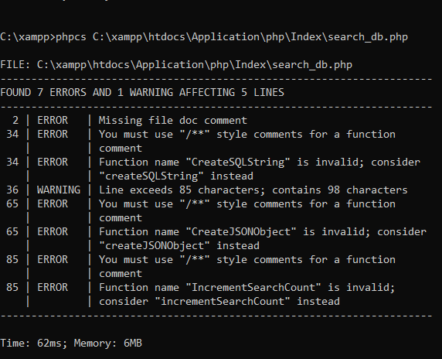

Initial amount of errors in search_db.php

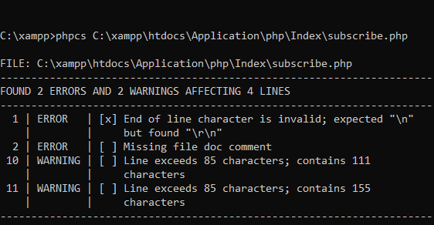

Initial amount of errors in subscribe.php

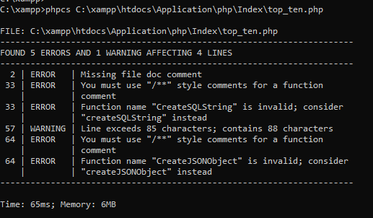

Initial amount of errors in top_ten.php

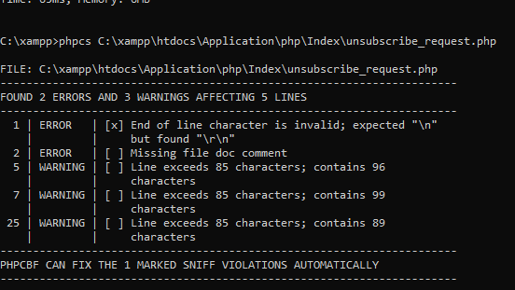

Initial amount of errors in unsubscribe_request.php

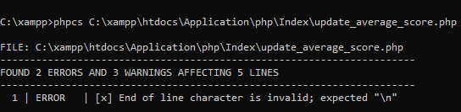

Initial amount of errors in update_average_score.php

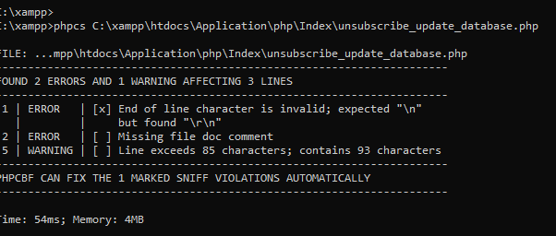

Initial amount of errors in unsubscribe_update_database.php

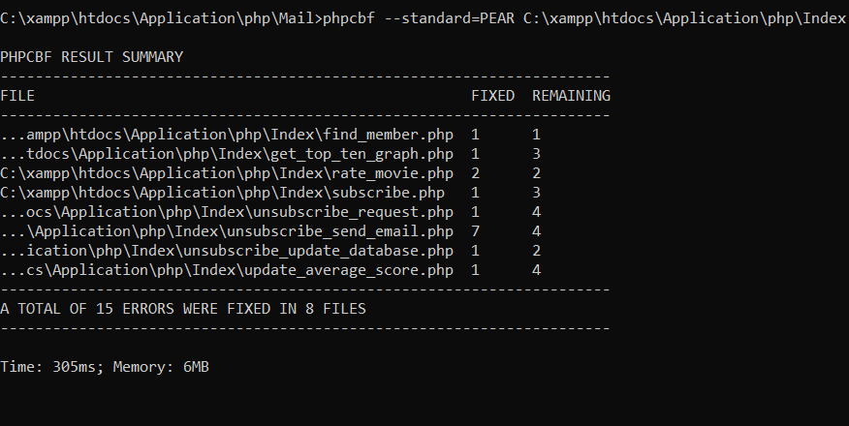

This shows the number of errors which have been fixed in the index file by using PHP CodeSniffer as well as the remaining amount of errors.

3.4 Mail

This is the number of issue resolved by using PHP Code Sniffer for the whole of Mailer php file.

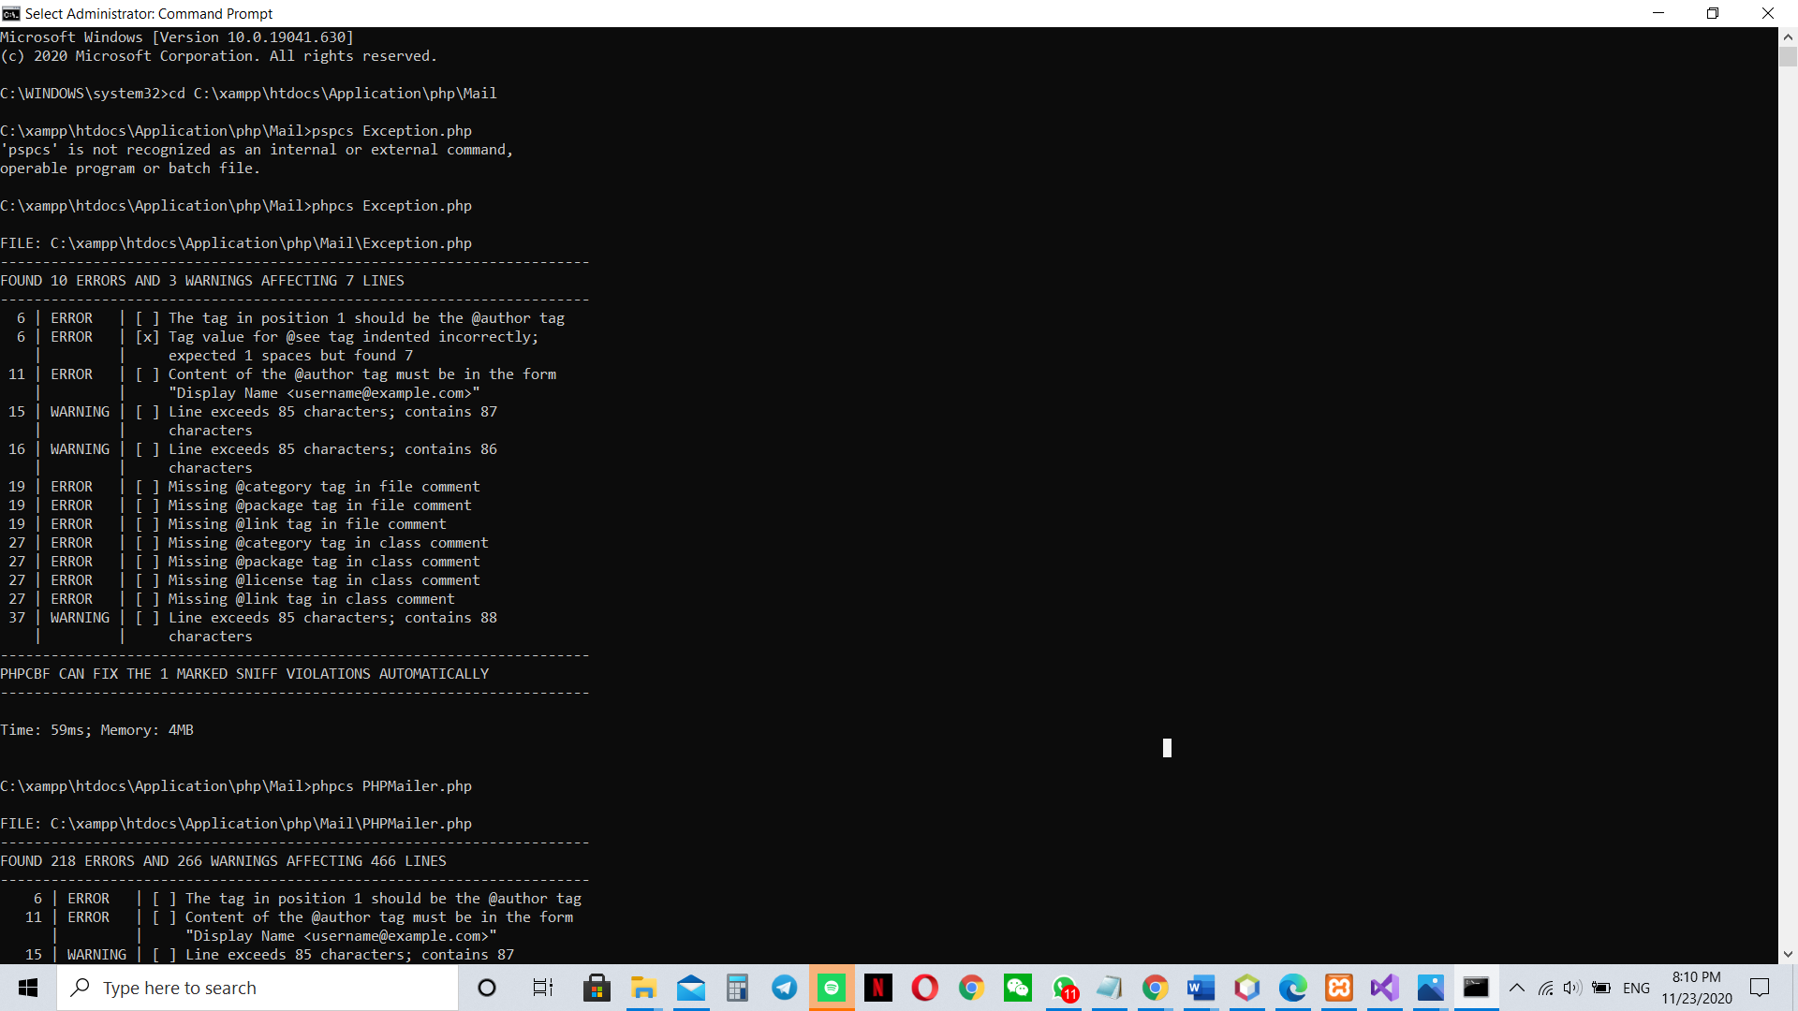

Initial amount of errors in Exception.php

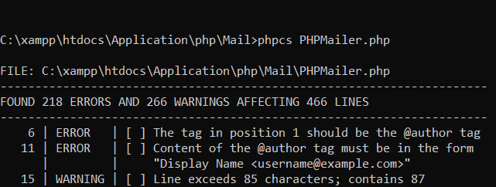

Initial amount of errors in PHPMailer.php

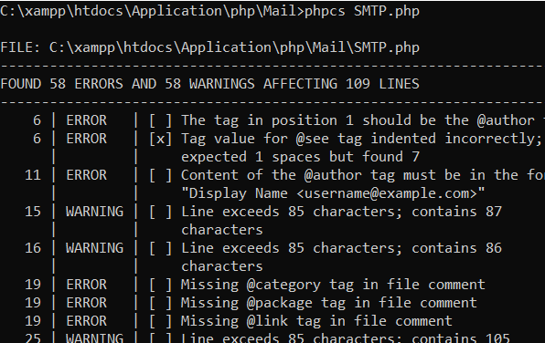

Initial amount of errors in SMTP.php

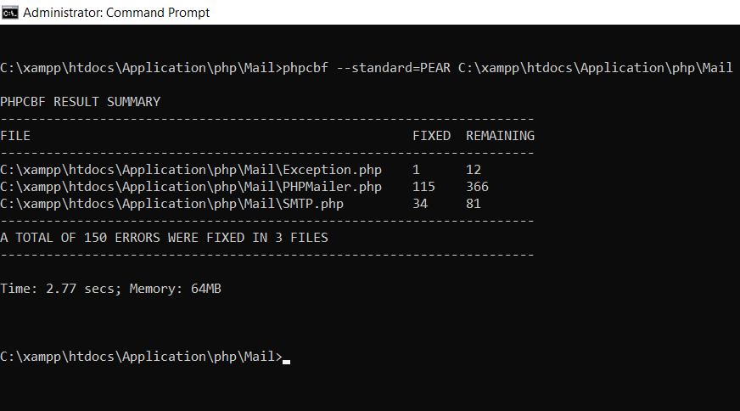

This shows the number of errors which have been fixed in the Mail file by using PHP CodeSniffer as well as the remaining amount of errors.